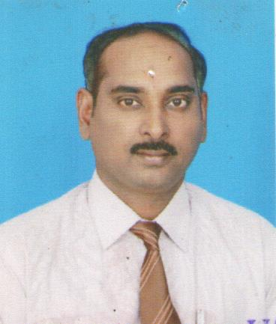  
 **Dr. R.VIJAYA BHASKAR  
 Lecturer in Commerce**

* Office: D.K. Govt.College for Women (A)
* Phone: 91 9440203138
* E-Mail: [rondlavb@gmail.com](mailto:rondlavb@gmail.com)
* Teaching Service:18 years

**Educational History**:

* Ph.D. , S.V.University Tirupati, A.P, 2007
* M.Phil., S.V.University Tirupati, A.P, 1998
* M.Com. , S.V.University Tirupati, A.P, 1995
* SLET Qualified in the 1999

**Research/ Seminars/ Publications:**

* 14 Research Papers published in International Journals
* 13 Seminars attended and papers presented
* 1OC, 2 RC and 2 Workshops attended
* One book published
* 1 M.Phil , Awarded